|  |
| --- |
| **Defensive Corner Kicks** |

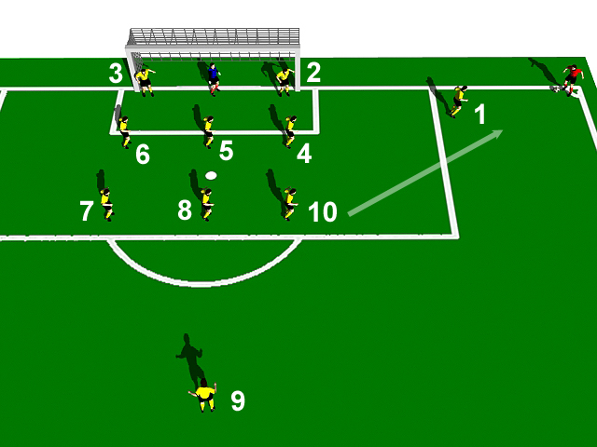

|  |
| --- |
| **Players Responsibilities:** |

1. **_______________:** Attack and distract the kicker. Start from end line if in swinging corner.

2. **_______________:** Mark area in front of near post. Tuck inside post if crossed deep.

3. **_______________:** Mark area in front of back post. Tuck inside post if crossed deep.

4. **_______________**: Mark Man for Man, second biggest player

5. **_______________:** Mark Man for Man, biggest player

6. **_______________:** Mark Man for Man

7. **_______________**: Mark Man for Man

8. **_______________:** Mark Man for Man, biggest player. Move across to fill space on penalty   
spot if a short corner is taken.

9. **_______________:** Stay up from as target man unless 2 v1 for short corner.

10. **_______________:** Move to 2v1 if played short

**If in doubt, knock it OUT**